NEWS TRACKER APPLICATION

Team ID: PNT2022TMID05148

CREATING UI TO INTERACT WITH APPLICATION

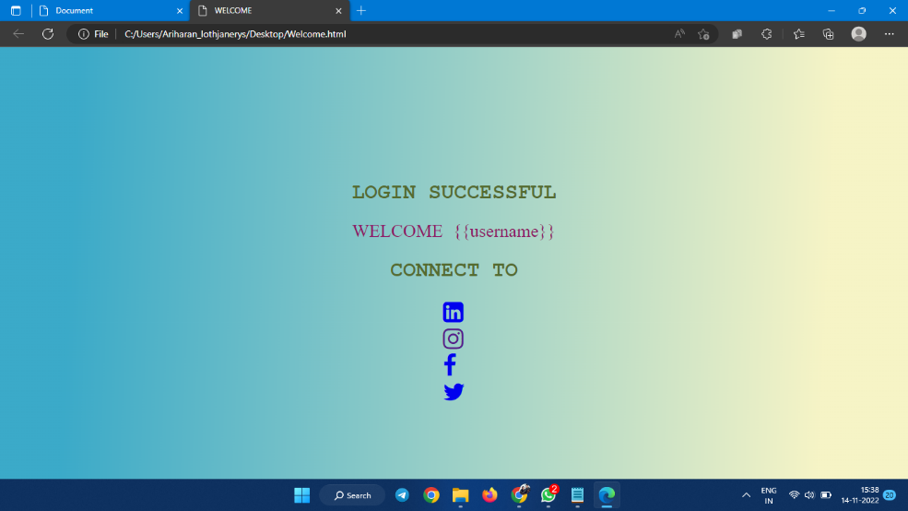

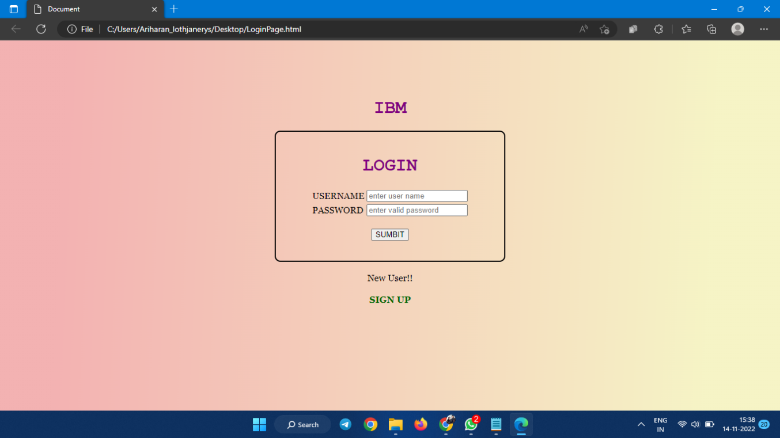

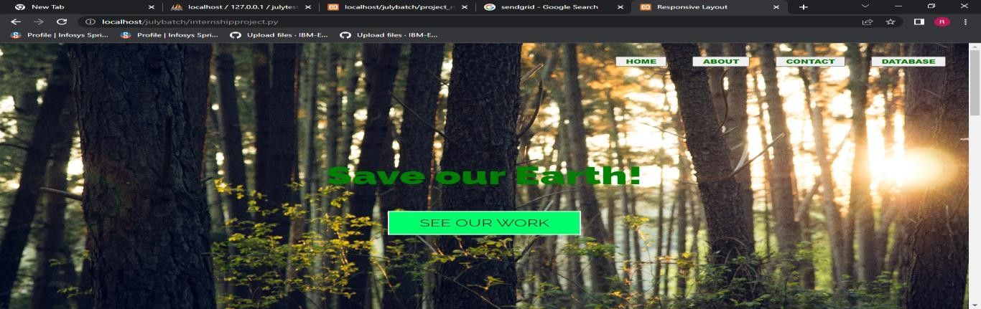

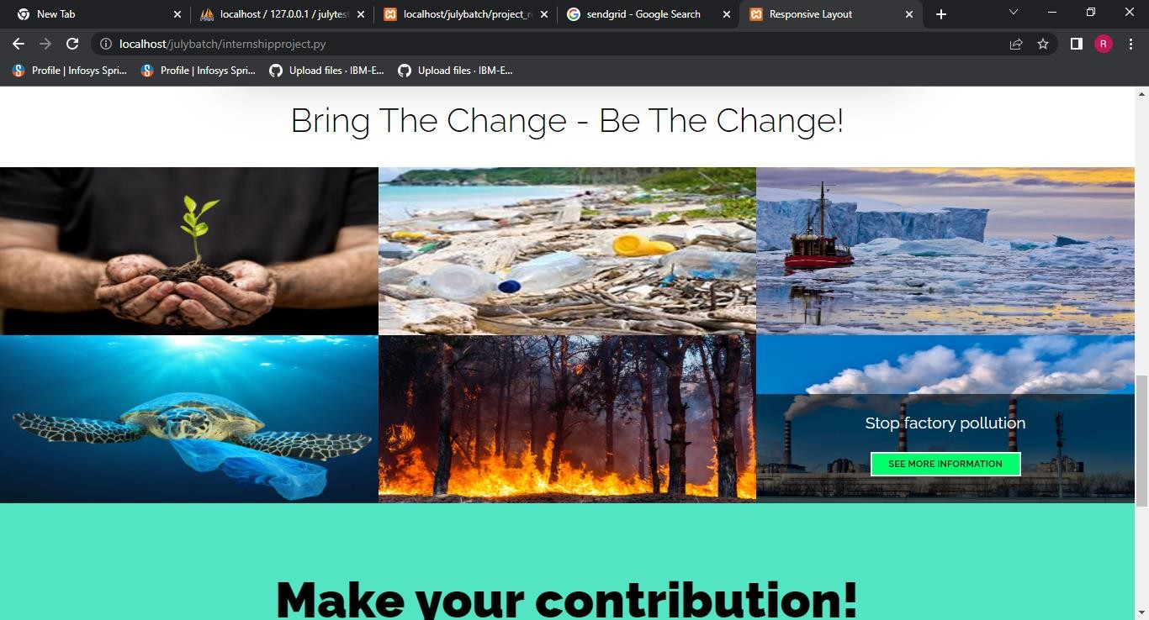

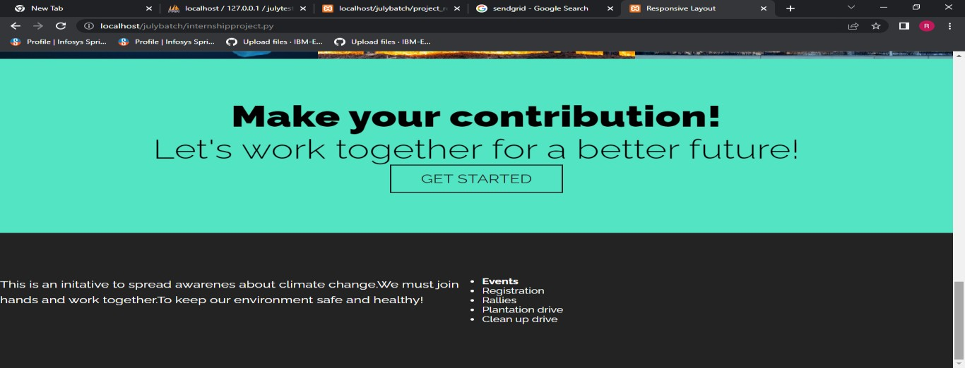

CREATE IBM DB2 AND CONNECT WITH PYTHON

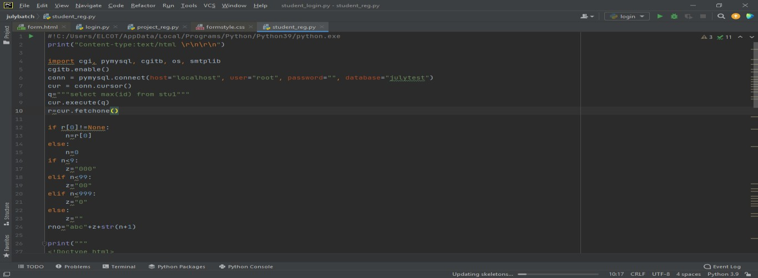

INTEGRATE RAPID API

